**Introduction**

This comprehensive analysis research into effect of additional textbook funding on school performance and specifically looking at average scores and math scores. By employing a variety of statistical models this study aims to isolate the influence of increased funding from other factors and to understand hints of its impact. The investigation covers different aspects like mean score differences, assumption checks, treatment effect estimates, robustness against covariate selection and a regression discontinuity design for causal inference.

**Impact of Funding on Scores**

**From Part 1**, the mean differences in average and math scores were negative (average: -0.8301, math: -0.7592) meaning that on average funded schools scored less than non-funded schools. The t-statistics were large and negative with corresponding p-values essentially at zero, which in statistical terms is very strong indication that these differences are unlikely to have occurred by chance alone. This suggests a real and underlying difference in scores between two groups.

However these results come with certain assumptions. The t-tests assume that schools outcomes are independent of each other and that variance of outcomes is equal between two groups which may not hold if funding tends to go to schools with more challenges. There also an assumption that differences are normally distributed. Any violation of these assumptions could potentially bias results.

**In Part 2** Average Treatment Effect (ATE) estimates for average scores and math scores were also negative and further supporting initial findings. The bootstrap method used to estimate standard errors that provides a measure of variability of ATE estimate. Small standard errors indicate estimates are precise and reinforcing conclusion that funding is associated with a decrease in scores.

The ATE relies on linearity of relationship between funding and scores and no omitted variable bias, random sampling and independence of observations. If any of these assumptions do not hold than it might affect reliability of ATE estimate.

**Assumption Violations**

Analysis involve adding a control for socio-economic status (SES) represented by percentage of students eligible for free or reduced lunch (percent). In the context of evaluating impact of extra textbook funding on average scores this is an essential step for several reasons:

**Controlling for Confounding:** SES is a known confounder in educational outcomes. By including percent regression model accounts for some of the variations in academic performance that arise from differences in SES and which may otherwise be attributed incorrectly to effect of textbook funding.

**Reducing Bias:** Without controlling for SES observed negative impact of extra textbook funding on average scores could be biased. This means that effect of funding might look more negative than it truly is because it is tangled up with effects of lower SES and which is also associated with lower academic performance.

**Isolating Impact of Funding:** By including percent in model you attempt to isolate effect of extra funding from effects of SES. If coefficient for extra funding decreases after this control is added and it suggests that some of the negative impacts previously attributed to funding were actually due to SES.

**Accurate Estimation:** Accurately estimating coefficient for extra funding is crucial for policymaking. Overestimating negative impact could lead to incorrect conclusions about effectiveness of funding initiatives. Equally underestimating impact could result in insufficient support for schools that need it.

**Methodological Difficulty**: Including relevant covariates like SES increases methodological severity of study. It demonstrates persistence in trying to account for all relevant factors that could influence outcome of interest and leading to more robust and reliable results.

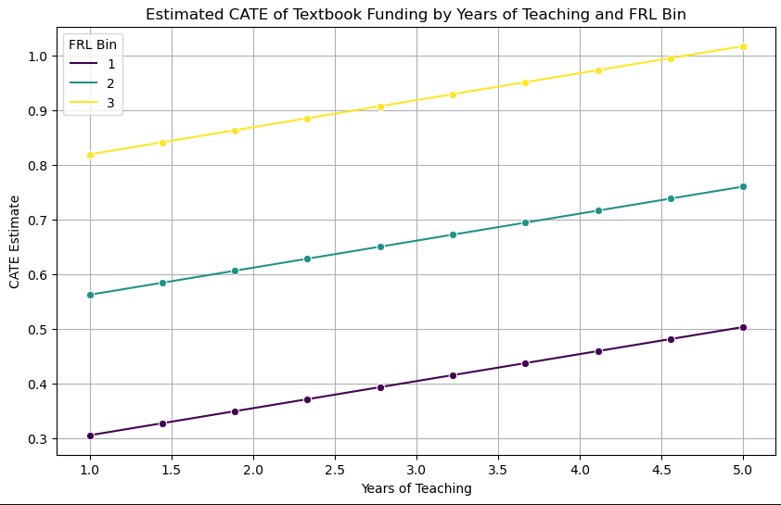

**Causal Analysis**

**Part 6 (Doubly Robust Estimation):**

The initial analysis using a doubly robust method suggests that schools that received extra textbook funding generally saw a decrease in their average scores. This method tried to correct biases that might distort the true effect of funding. The negative ATE along with standard error and suggests that this finding is reliable and that funding is associated with lower scores.

**Part 7 (Propensity Score Distribution):**

When we look at distribution of propensity scores which measure likelihood of a school receiving extra funding and we find a good overlap between schools that received funding and those that did not. This overlap is crucial because it means we can fairly compare two groups. However at the very low end of the propensity scores there is little overlap that suggesting that comparison might not be as reliable for schools that had a very low chance of receiving extra funding.

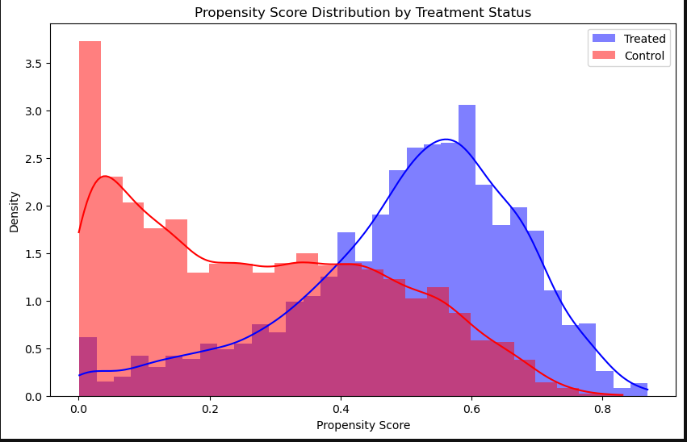

**Part 8 (Machine Learning Approach):**

A machine learning approach was used to predict effect of extra textbook funding on average scores. This method which can account for more complex relationships and suggests that funding decreases average scores. The reliability of this effect depends on there being a satisfactory overlap in characteristics of schools that received funding and those that did not.

**Part 9 (Including All Covariates):**

When all possible influencing factors covariates are included in analysis and effect of extra funding on average scores essentially disappears it’s as if there is no effect at all. The standard error which measures how much we expect estimate to vary if we were to repeat study amd is very small. This gives us confidence that ATE being zero is a precise estimate.

**Part10:**

The results from this analysis show a positive estimated mean difference meaning schools just above funding cutoff (receiving extra funding) had higher average scores than schools just below the cutoff. This is contrary to what was found in earlier parts where extra funding was associated with lower scores.

The estimated mean difference is approximately 0.2385 which is statistically significant given very small p-value essentially zero. The t-statistic of about 5.16 further supports significance of this finding. A high t-statistic and a low p-value together indicate that observed difference in scores between funded and non-funded schools is unlikely to be due to random chance.

The discussion suggests that this RDD approach is likely giving a more accurate picture of true causal effect of textbook funding for schools near funding cutoff. This contrasts with previous estimates that may have included biases from comparing schools that were not directly comparable or were far from funding eligibility threshold.

**Evaluating Discontinuity in Educational Funding and Outcomes**

**Part 11: Analysis of Funding Allocation**

The bar plot of textbook funding per student across bins that is organized by a normalized difference to a cutoff point amnd it is designed to visually examine if there is a distinct jump or drop in funding at cutoff. This visualization is key in a sharp regression discontinuity design (RDD) which assumes that only difference between groups on either side of threshold is treatment effect in this case the additional funding. The expectation is to see a clear difference in funding at cutoff point if RDD assumptions hold true.

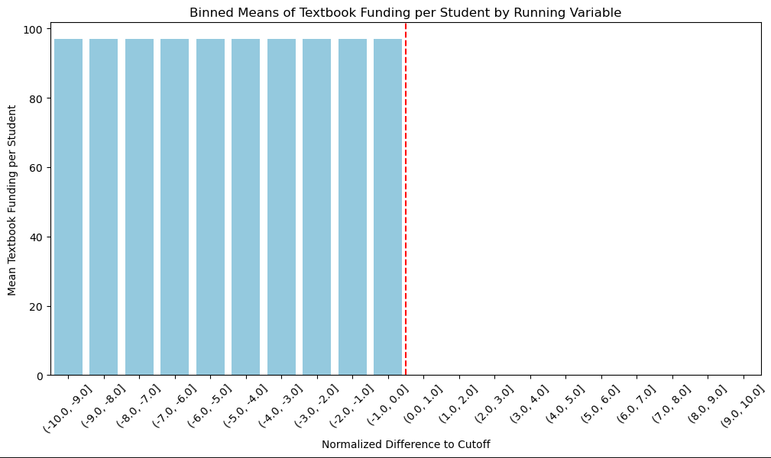

**Part 12: Checking for Discontinuity in Average Scores**

The analysis continues with a similar binned approach and this time looking at average scores rather than funding. The lack of a discontinuity in average scores around cutoff suggests that receiving extra textbook funding does not correspond to a sudden change in average scores.

**Part 13: Visual Examination of Discontinuity**

A scatter plot with a polynomial fit on either side of funding eligibility cutoff provides a visual test for continuity. The goal here is to detect any immediate jumps at cutoff that would imply a causal effect. While there appears to be a slight discontinuity and suggesting a potential effect of funding on scores analysis calls for a formal statistical test to establish whether this observation can be confidently attributed to funding itself.

**Part 14**

**Legal Framework:** The Williams settlement which is a legal resolution addressing educational disparities particularly in underserved communities comes with stringent legal oversight. Such measures ensure that the settlement's provisions are enforced fairly and impartially thus minimizing potential for manipulating allocation based on academic metrics.

**Transparency and Accountability:** The settlement terms are typically clear and public specifying criteria for how resources are allocated. The authorities responsible for allocation are held accountable to public and various interest groups that ensuring that processes are transparent and adhere strictly to established criteria.

**Public Scrutiny**: Decisions regarding allocation of educational funds and resources and especially under high-profile settlements like Williams are subject to public examination. Any suspected fraud or bias in the assignment of these resources particularly those related to academic metrics would likely face public opposition and possibly lead to further legal action.

**Data Integrity and Monitoring**: Educational authorities often implement rigorous systems for data collection and monitoring to preserve accuracy of academic metrics. These systems are designed to identify and address any data anomalies or irregularities that might suggest manipulation.

**Stakeholder Involvement:** The execution of Williams settlement often requires collaboration among various stakeholders including educators community members and advocacy groups. The involvement of a diverse array of parties helps ensure that decisions regarding resource allocation are just and consistent with settlement's goals​​​​​​​​​​.

**In Part 15** its focus is on use of polynomial regression within the RDD framework. Polynomial terms (linear, quadratic, cubic) are introduced into regression model to investigate if there's a more complex relationship between running variable (normalized score) and outcome variable (average score). This method helps to explore whether impact of funding on scores changes at a rate that isn't constant that which might be missed by a simple linear model. However results from cubic model indicate that even after considering these polynomial terms effect of funding on average scores remains significant. This suggests that additional complexity in model does not explain away the effect providing further confidence in robustness of RDD approach. And note of caution is added regarding multicollinearity and other numerical issues as indicated by a large condition number in the model output. This signals that model may have included highly correlated predictor variables which can affect reliability of regression coefficients estimated​​.

**Robustness of Estimates (Part 16 to 18):**

**In Part 16** analysis explain RDD approach by plotting average scores of schools in relation to their distance from funding eligibility cutoff. It incorporates linear and quadratic predictions to assess if relationship between receiving funding and average scores is simple or more complex:

**Observed Scores (green bars):** These are actual average scores for each bin based on the school's proximity to funding eligibility cutoff.

**Linear Prediction (blue line):** This line represents expected scores if relationship between funding and scores was simply proportional as distance from the cutoff increases or decreases and scores would change at a constant rate.

**Quadratic Prediction (red line):** This curve shows expected scores if theres a more complex and non-linear relationship.The impact of funding might start small but then grows more quickly (or less) as you move away from cutoff.

The graph aims to determine whether funding's effect on scores changes at a consistent rate or varies depending on how close a school is to funding threshold. It part of checking validity of RDD model.

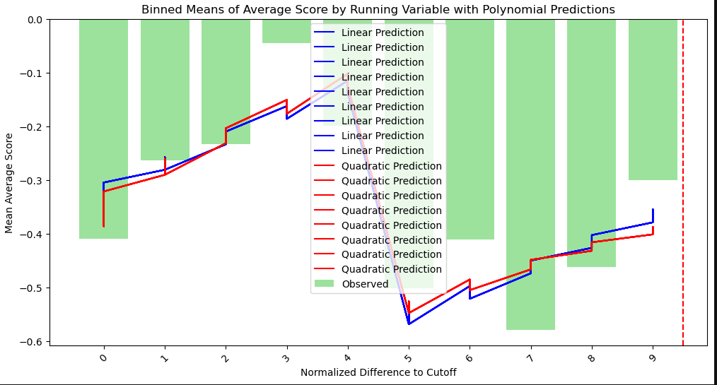

**Part 17** discusses process of selecting an appropriate bandwidth when using local linear regression with a K-Nearest Neighbors Regressor to estimate treatment effect of funding. Bandwidth here refers to range of data points considered around cutoff point and which can influence estimated effect:

**Small Bandwidth:** A tighter focus around cutoff may reflect more immediate impact of funding but could result in high variability in estimates due to overfitting to local fluctuations in the data.

**Large Bandwidth:** A broader focus might capture more data points but could also smooth over important variations and potentially missing localized effects of funding.

The analysis uses different bandwidths to see how choice affects estimated treatment effect. The negative treatment effects calculated across tested bandwidths consistently suggest that schools receiving extra textbook funding are associated with lower average scores.

**Part 18** continues this examination by using grid search techniques to find "best" bandwidth optimal number of neighbors in the KNN algorithm aiming to achieve a good balance between bias and variance in treatment effect estimation. The best-fit model suggests an even larger negative effect of funding on average scores when using optimal bandwidth and again indicating that schools with extra funding tend to have lower average scores.

**Final Conclusions**

Impact of Extra Textbook Funding on Scores: Schools that received additional textbook funding generally had lower average and math scores compared to those that did not receive such funding. This was found through mean difference calculations and t-tests and both of which were statistically significant which suggesting a real difference beyond random chance​​.

Influence of Covariates: Including covariates such as percentage of students eligible for free or reduced lunch (percent) aimed to control for socioeconomic status (SES). The inclusion of these variables significantly changed estimated average treatment effect (ATE), ultimately suggesting no visible effect of extra textbook funding on average scores once all factors were accounted for​​.

Regression Discontinuity Design (RDD): An RDD analysis indicated a more shade understanding of causal impact of funding. It suggested that for schools near eligibility threshold for funding and previously observed effects might have been influenced by biases or were reflecting an average treatment effect that included schools far from cutoff​​.

Machine Learning Approaches: Using methods like local linear regression with K-nearest neighbors and cross-fitting with machine learning models provided estimates of treatment effect and accounted for complex relationships between variables. These models which can capture more complex interactions and suggested that extra textbook funding is associated with a decrease in average scores​​.

Bandwidth Selection in RDD: The selection of bandwidth in local linear regression is crucial as it affects bias-variance trade-off. Smaller bandwidths can lead to more precise but potentially noisier estimates whereas larger bandwidths might smooth out significant local variations. Grid search methods were used to determine best bandwidth and finding that a larger number of neighbors led to a significant negative treatment effect​​.

ATE Estimates and Doubly Robust Estimation: Initial ATE estimates indicated a significant negative impact of extra funding on scores but upon including all covariates ATE changed to a value close to zero. This illustrates importance of accounting for all relevant variables in observational studies to avoid misleading conclusions​​.

Interactions and CATE Estimation: When interactions were accounted for estimated mean difference in scores due to funding was significant and suggesting an effect of funding on average scores​​.

**References:**

1. Holden, K.L., 2016. 'Buy the Book? Evidence on the Effect of Textbook Funding on School-Level Achievement', American Economic Journal: Applied Economics, 8(4), pp. 100-127.
2. Sohn, H., Park, H. and Jung, H., 2023. 'The Effect of Extra School Funding on Students’ Academic Achievements under a Centralized School Financing System', Education Finance and Policy, 18(1), pp. 1–24.
3. Holden, K., 2016. 'Buy the Book? Evidence on the Effect of Textbook Funding on School-Level Achievement', American Economic Journal: Applied Economics, 8, pp. 100-127.
4. Post, R.A.J., Petkovic, M., van den Heuvel, I.L. and van den Heuvel, E.R., 2024. 'Flexible Machine Learning Estimation of Conditional Average Treatment Effects: A Blessing and a Curse', Epidemiology, 35(1), pp. 32-40.
5. Rong, S. and Bao-wen, Z., 2018. 'The research of regression model in machine learning field', MATEC Web of Conferences, 176.